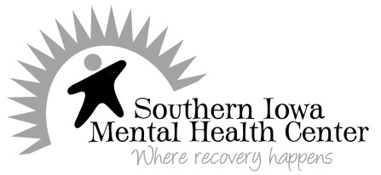
Potential Achievers: CONSENT FORM

Potential Achievers is a joint venture between Southern Iowa Mental Health Center and the Ottumwa Community School District’s elementary schools. Our purpose is to assist students in dealing with personal or behavioral problems that interfere with success in school. Students can be referred to the program by teachers, administrators, guidance counselors, school nurses, parents, other caretakers, and outside agencies. These services are offered at no charge to families and are led by licensed therapists or co-lead by master’s level mental health interns under the direct supervision of the licensed therapist. Parental consent for the program is required and must be approved by a guardian with joint legal and medical custody.
Client Rights and Responsibilities: I understand that it is my right to ask questions if I need clarification or have concerns.
Confidentiality: I understand that what I share or what my child shares in the course of working with Potential Achievers is private and confidential and my child’s records are protected under state and federal regulations governing confidentiality unless otherwise noted in the privacy notice attached. I understand that information regarding my child’s care may be shared internally at Southern Iowa Mental Health Center with other professional staff persons to assure effective treatment and the minimum needed with support staff to maintain records. My child’s records will consist of this consent form, release to exchange information with the school and other, related therapist notes, plus related correspondence from outside agencies.
Acknowledgement of Child and Dependent Adult Abuse/Neglect Reporting: I understand that all health and human service professionals are required by state law to report suspected abuse or neglect to the appropriate authorities.
If you have any questions about this, please feel free to ask for better understanding before you sign. My signature below acknowledges my understanding.
Consent for Services: I authorize Southern Iowa Mental Health Center to provide services through the Potential Achievers program for the below named child.
Child’s name: Child’s DOB: __________________
Parent/Guardian’s name:
Parent/Guardian’s address:
Parent/Guardians’ Phone Number:
Authorizing Signature: The consent noted above is valid for the current school year. A copy of this document is considered as valid as the original. I may send a written notice to SIMHC at any time to revoke this consent except to the extent that action has been taken in reliance on it.
___________________________________________________ ____________________________
Signature of Parent/Guardian Date

___________________________________________________ ____________________________ Witness Signature Date

